**MOHIN KHAN**

**B tech (CSE) 3rd year**

**PERSONAL DETAILS :**

**Name : Mohin khan**

**D.O.B : 04/AUG/2001**

**Nationality : Indian**

**language known : Hindi,English**

**Address : Hirdiyapur Bhandola,**

**Modinager(GZB , UP)**

**CONTACT :**

**PHONE : 7456917763**

**EMAIL : mohin745691@gmail.com**

**HOBBIIES :**

**Learn new new things**

**Traveling**

**Exploring technologies**

**Music**

**STRENGTHS :**

**Good Communication Skill**

**Self Motivation and Self Confidence**

**Positive Outlook**

**Honesty Behaviour**

**Adoptability to Changing Environment**

**CAREER OBJECTUVE :**

Intend to build a career with leading corporate environment with committed and dedicated people,which will help me to explore myself fully and satisfy my zeal for innovative creations in the field of Technology.

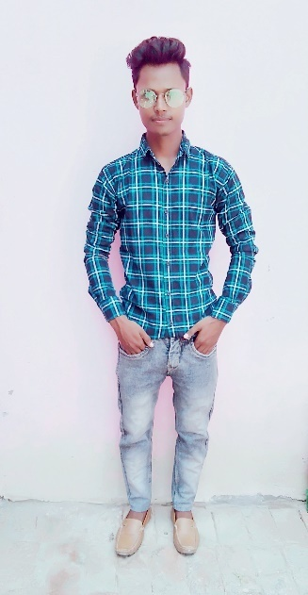

**EDUCATION :**

**R D Engineering Collage Duhai, Ghaziabad**

B. TECH (Computer Science engineering) 3rd year

**Dr K.N Modi Engineering Collage Modinager (GZB)**

Diploma BTEUP (CSE Passed 2021) 79% marks

**S A INT COLL SAIDPUR MODINAGER GHAZIABAD**

XII Standered UP Board (passed 2019) 63% marks

**Shri Ram Inter Collange Modinager**

X Stsndered UP Board (Passed 2017) 72% marks

**TECHNICAL SKILLS**

Basic knowledge of computer

**Technical language :**

C,C++,Java,Html,CSS

**PROJECT**

LIBERARY MANAGEMENT (3rd YEAR)

Calculator for java

**Extra-Curricular Activites& Achievments**

Amazon Web Services (AWS) Trained.

I got C,JAVA,DSA Certificate from Zeal Educates and Python certificate from coding ninjas.

LINKS

**Github link :https://github.com/Mohinkhan0**